1+ (614) 266-1211 CATALOG

Affordable Cyc Wall Systems makes custom cyclorama walls to your exact specifications. We offer 3 basic Cyc Wall shapes:
Straight Wall
horizontal inserts in a variety of sizes: 18”, 24”, 34”, 45” radius cove.
L-shape
2 horizontal walls and 1 vertical corner inserts in two sizes: 24” horizontal radius cove w/ 34” vertical radius cove corner
34” horizontal radius cove w/ 45” vertical radius cove corner
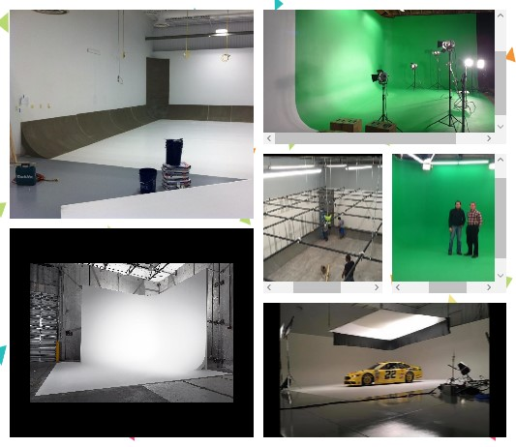
U-shape
3 horizontal walls and 2 vertical corner inserts in two sizes: 24” horizontal radius cove w/ 34” vertical radius cove corner
34” horizontal radius cove w/ 45” vertical radius cove corner
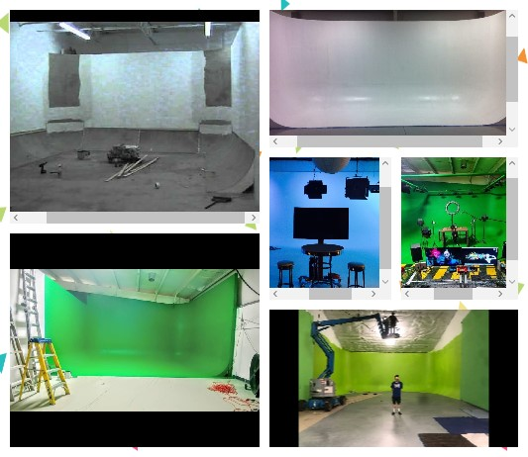

Affordable Cyc Wall Systems Ceiling Inserts
Ceiling inserts are usually installed with a U-shape Cyc Wall or entire room Cyc Wall. If you order ceiling inserts ideally they should match the size of your horizontal floor insert system. Ceiling inserts come in two sizes: 24” horizontal radius cove w/ 34” vertical radius cove corner
34” horizontal radius cove w/ 45” vertical radius cove corner
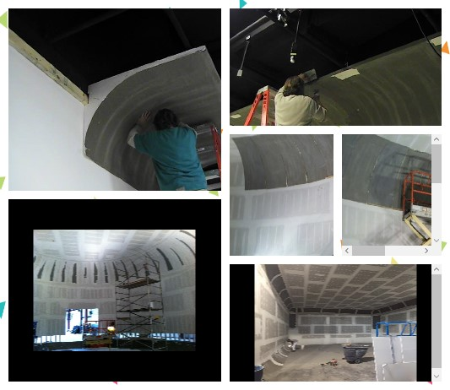
Get creative with an Affordable Cyc Wall System TODAY!

